

**A Project**

Report On

**Automation testing using java class on PARABANK website**

**By,**

**Sowmya S**

**Batch: SOC-5216**

**Under the Guidance of,**

**Priyanka Desle**

**(Technical Trainer)**

**EduBridge**

**Introduction:**

This Project aims to do overall testing like functional testing, GUI testing on website to check quality of application. It helps to improve quality of website and saves time for manually doing this testing. In this project our main focus is to check functionalities available on website. Also it includes title check and all links count with their working status.

**Software Requirements:**

Operating System: Window 10

Browser: Latest version of Firefox

IDE: Eclipse IDE

Front-end: Java

|  |
| --- |
| **TC01 -** Launch the browser and open the Parabank website |

System.*setProperty*("webdriver.gecko.driver", "C:\\Users\\SOWMYA\\Desktop\\jar files\\firefox\\geckodriver.exe");

WebDriver w = **new** FirefoxDriver();

w.get("https://parabank.parasoft.com/parabank/index.htm");

Thread.*sleep*(1000);

|  |
| --- |
| **TC02 –** To test the functionality of Home button |

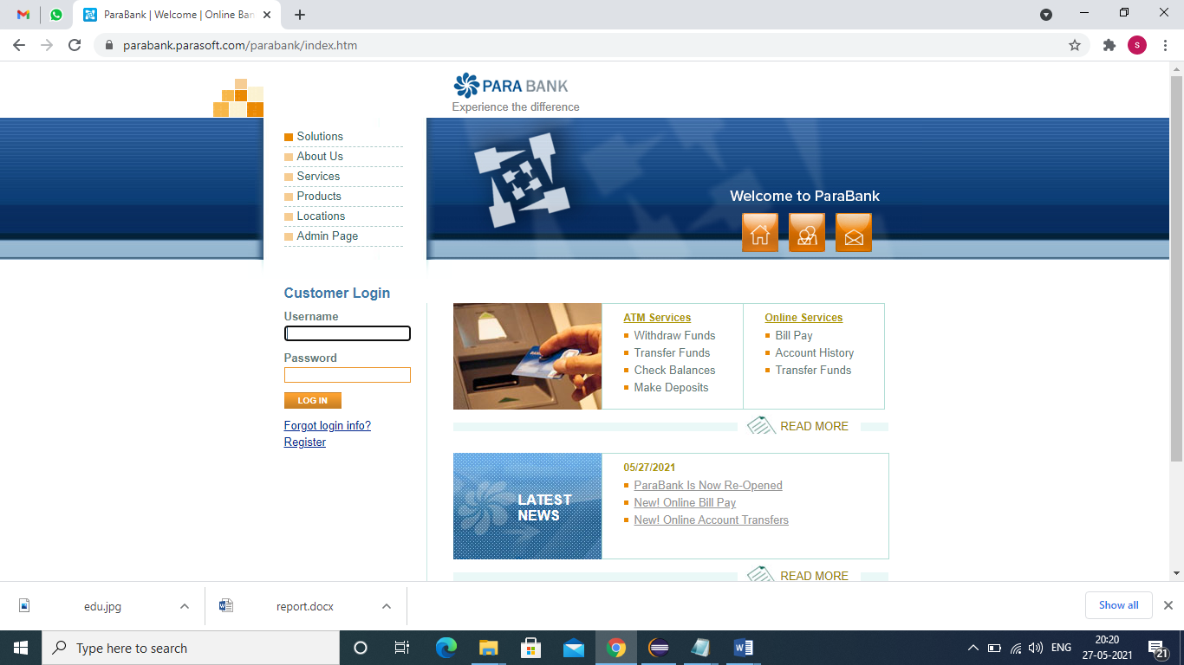

w.findElement(By.linkText("home")).click();

|  |
| --- |
| **TC03 –** To test the functionality of the Withdraw funds button |

w.findElement(By.linkText("Withdraw Funds")).click();

Thread.sleep(2000);

w.navigate().back();

Thread.sleep(2000);

|  |
| --- |
| **TC04 –** To test the functionality of Transfer funds button |

w.findElement(By.*linkText*("Transfer Funds")).click();

Thread.*sleep*(2000);

w.navigate().back();

Thread.*sleep*(2000);

|  |
| --- |
| **TC05 –** To test the functionality of Check balance button |

w.findElement(By.*linkText*("Check Balances")).click();

Thread.*sleep*(2000);

w.navigate().back();

Thread.*sleep*(2000);

|  |
| --- |
| **TC06 –** To test the functionality of Make deposit button |

w.findElement(By.*linkText*("Make Deposits")).click();

Thread.*sleep*(2000);

w.navigate().back();

Thread.*sleep*(2000);

|  |
| --- |
| **TC07 –** To test the functionality of Bill pay button |

w.findElement(By.*linkText*("Bill Pay")).click();

Thread.*sleep*(2000);

w.navigate().back();

Thread.*sleep*(2000);

|  |
| --- |
| **TC08 –** To test the functionality of Account history button |

w.findElement(By.*linkText*("Account History")).click();

Thread.*sleep*(2000);

w.navigate().back();

Thread.*sleep*(2000);

|  |
| --- |
| **TC09 –** To test the functionality of Transfer funds button |

w.findElement(By.*xpath*("//body/div[@id='mainPanel']/div[@id='bodyPanel']/div[@id='rightPanel']/ul[2]/li[4]/a[1]")).click();

Thread.*sleep*(2000);

w.navigate().back();

Thread.*sleep*(2000);

|  |
| --- |
| **TC10 –** To test the functionality of Read me button |

w.findElement(By.*xpath*("//body/div[@id='mainPanel']/div[@id='bodyPanel']/div[@id='rightPanel']/p[1]/a[1]")).click();

w.findElement(By.*xpath*("//body[1]/div[1]/div[3]/div[2]/table[1]/tbody[1]/tr[1]/td[2]/a[1]")).click();

Thread.*sleep*(2000);

w.navigate().back();

Thread.*sleep*(2000);

w.navigate().back();

Thread.*sleep*(2000);

|  |
| --- |
| **TC11 –** To test the functionality of Parabank is now re-opened |

w.findElement(By.*linkText*("ParaBank Is Now Re-Opened")).click();

Thread.*sleep*(2000);

w.navigate().back();

|  |
| --- |
| **TC12 –** To test the functionality of read me button |

w.findElement(By.*xpath*("//body/div[@id='mainPanel']/div[@id='bodyPanel']/div[@id='rightPanel']/p[2]/a[1]")).click();

Thread.*sleep*(2000);

w.navigate().back();

Thread.*sleep*(2000);

|  |
| --- |
| **TC13 –** To test the functionality About us button |

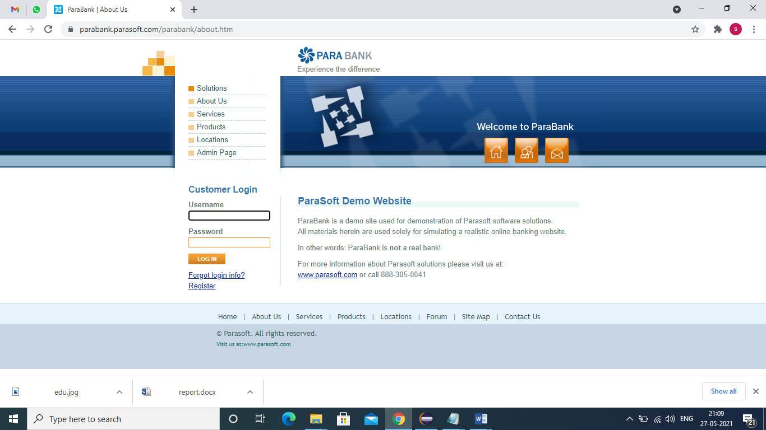

w.findElement(By.*linkText*("about")).click();

|  |
| --- |
| **TC14 –** To test the functionality of the link test button |

w.findElement(By.*xpath*("//body/div[@id='mainPanel']/div[@id='bodyPanel']/div[@id='rightPanel']/p[3]/a[1]")).click();

Thread.*sleep*(2000);

w.navigate().back();

Thread.*sleep*(2000);

|  |
| --- |
| **TC15 –** To check the functionality of Customer care button |

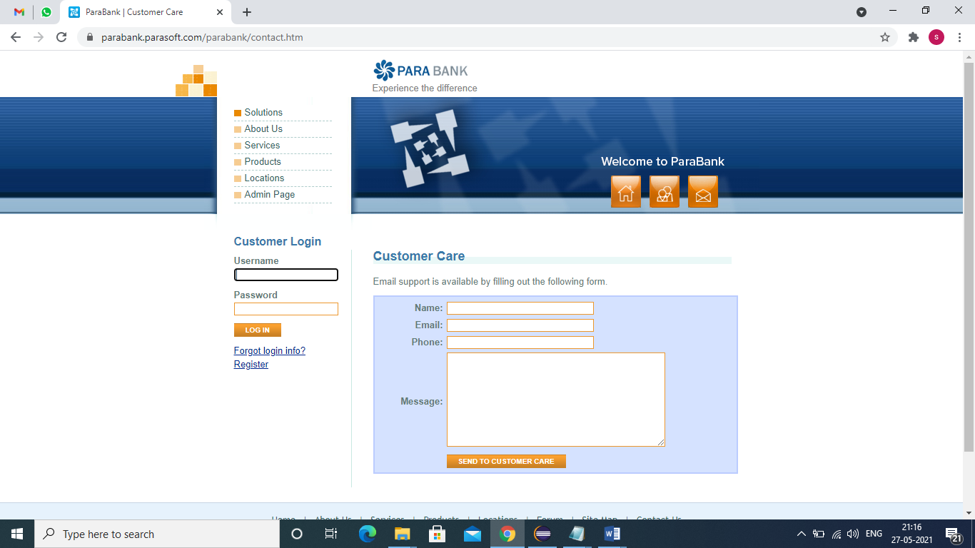

w.findElement(By.*linkText*("contact")).click();

|  |
| --- |
| **TC16 –** To test the functionality of send to customer care button |

w.findElement(By.*id*("name")).sendKeys("abcd");

w.findElement(By.*id*("email")).sendKeys("abcd@gmail.com"); w.findElement(By.*id*("phone")).sendKeys("1234567890");

w.findElement(By.*id*("message")).sendKeys("good");

w.findElement(By.*xpath*("//tbody/tr[5]/td[2]/input[1]")).click();

Thread.*sleep*(2000);